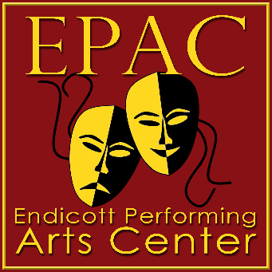
The EPAC Devin Spears Memorial Scholarship
The EPAC Devin Spears Memorial Scholarship was created in memory of a student in The Endicott Performing Art Center’s Kids’ Theater Workshop who tragically passed away. The committee awarding the scholarships will consist of the Artistic Executive Director and Business Manager of the Endicott Performing Arts Center and the scholarship winners will be confirmed by the EPAC Board of Directors.

Criteria: Award given to a graduating senior who will be pursuing higher education in the arts.
Award Amount: $300 - 500
Application:
First name: ___________________________ Last Name: _____________________________________
Address: _____________________________________________________ Birth Date: ______________
City/State/Zip: ________________________________________________
Email: _______________________________________________________
Where will you be pursuing your higher education?
Name of school: _______________________________________________________________________
Address of school ______________________________________________________________________
Major/Minor fields of study? _____________________________________________________________
In an essay of one hundred fifty words minimum, describe your future plans and why you believe you deserve this scholarship. Please type and attach sheet to application.
Teacher recommendation: _______________________________________________________________
(Teacher’s signature) (Date)
Teacher’s comments: _____________________________________________________________________________________ _____________________________________________________________________________________ _____________________________________________________________________________________ _____________________________________________________________________________________ _____________________________________________________________________________________ _____________________________________________________________________________________ _____________________________________________________________________________________
Applications must be completed and returned to the Endicott Performing Arts Center no later than May First.
Please mail to EPAC, 102 Washington Ave., Endicott, NY or email it to epacoffice102@gmail.com.

